Baldivis Secondary College

Semester Two Examination, 2017

Question/Answer booklet

MATHEMATICS

SOLUTIONS
APPLICATIONS
UNITS 1 AND 2

Section Two:

Calculator-assumed

Student Number: In figures

In words

Your name

Time allowed for this section
Reading time before commencing work: ten minutes
Working time: one hundred minutes

Materials required/recommended for this section
To be provided by the supervisor
This Question/Answer booklet
Formula sheet (retained from Section One)

To be provided by the candidate
Standard items: pens (blue/black preferred), pencils (including coloured), sharpener, correction fluid/tape, eraser, ruler, highlighters

Special items: drawing instruments, templates, notes on two unfolded sheets of A4 paper, and up to three calculators approved for use in this examination

Important note to candidates
No other items may be taken into the examination room. It is your responsibility to ensure that you do not have any unauthorised material. If you have any unauthorised material with you, hand it to the supervisor before reading any further.

Structure of this paper

Section | Number of questions available | Number of questions to be answered | Working  time (minutes) | Marks available | Percentage of examination
Section One:  Calculator-free | 6 | 6 | 50 | 52 | 35
Section Two:  Calculator-assumed | 13 | 13 | 100 | 98 | 65
 |  |  |  | Total | 100

Instructions to candidates

1. The rules for the conduct of examinations are detailed in the school handbook. Sitting this examination implies that you agree to abide by these rules.

2. Write your answers in this Question/Answer booklet.

3. You must be careful to confine your response to the specific question asked and to follow any instructions that are specified to a particular question.

4. Additional working space pages at the end of this Question/Answer booklet are for planning or continuing an answer. If you use these pages, indicate at the original answer, the page number it is planned/continued on and write the question number being planned/continued on the additional working space page.

5. Show all your working clearly. Your working should be in sufficient detail to allow your answers to be checked readily and for marks to be awarded for reasoning. Incorrect answers given without supporting reasoning cannot be allocated any marks. For any question or part question worth more than two marks, valid working or justification is required to receive full marks. If you repeat any question, ensure that you cancel the answer you do not wish to have marked.

6. It is recommended that you do not use pencil, except in diagrams.

7. The Formula sheet is not to be handed in with your Question/Answer booklet.

Section Two: Calculator-assumed 65% (98 Marks)
This section has thirteen (13) questions. Answer all questions. Write your answers in the spaces provided.

Working time: 100 minutes.

Question 7 (6 marks)
(a) If concrete can be bought for $290 per cubic metre, calculate the total cost and the cost per square metre to make a rectangular concrete slab measuring 8.5 m by 7.4 m and with a uniform thickness of 200 mm. (3 marks)
Solution
$$A=8.5×7.4=62.9 {\text{m}}^{2}$$
$$V=62.9×0.200=12.58 {\text{m}}^{3}$$

$$C=12.58×290=\$3648.20$$

$$\text{Cost per }{\text{m}}^{2}=3648.20÷62.9=\$58.00$$

Specific behaviours
calculates slab volume
calculates slab cost
calculates slab cost per m²

(b) After pouring another rectangular concrete slab, the builder wanted to check that the corners of the slab were right-angled. The builder measured the diagonal of the slab to be 8.9 m and the sides of the slab to be 3.9 m and 7.9 m.

Use your knowledge of mathematics to determine whether the corners of the slab were right-angled. (3 marks)
Solution
$${3.9}^{2}+{7.9}^{2}=15.21+62.41=77.62$$

$${8.9}^{2}=79.21$$

As sum of squares of two shorter sides is not equal to square of diagonal, then the triangle doesn't satisfy Pythagoras' Theorem, and so the angle in the corner is not a right-angle.

Specific behaviours
uses Pythagoras' Theorem
adds squares of two shorter sides
writes conclusion

Question 8 (5 marks)
Six variables are listed below.

A Hotel rating using a scale of 1 to 5 stars
B How many cousins a person has
C Weight of a person
D Club membership number
E Throws of a dice to get a six
F Average daily temperature

(a) In the spaces below, write the letter corresponding to one of the above of variables that is

(i) a numerical variable that can be classified as continuous. (1 mark)
Solution
C or F

Specific behaviours
suitable variable

(ii) a numerical variable that can be classified as discrete. (1 mark)
Solution
B or E

Specific behaviours
suitable variable

(iii) a categorical variable that can be classified as ordinal. (1 mark)
Solution
A or D

Specific behaviours
suitable variable

(b) Give an example of a categorical variable that is not listed above and can be classified as nominal. Explain why it has this classification. (2 marks)
Solution
Hair colour.

The value of such variables can be obtained by observation and do not have any order.

Specific behaviours
suitable variable
explanation

Question 9 (6 marks)
From the top of a $25$ m tall building, the angle of depression to a small animal sitting on a path, level with the base of the building, is $18°$.

(a) Calculate the distance the animal is from the base of the building. (3 marks)
Solution
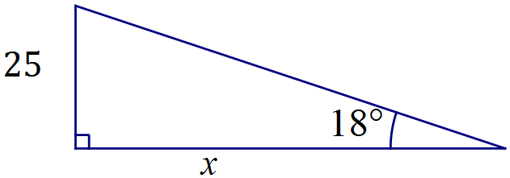

$$\tan{18}=\frac{25}{x}⇒x=76.9 \text{m}$$

Specific behaviours
sketch diagram with measurements
uses tangent ratio
states distance

The animal walks $25$ m directly away from the building and then stops.

(b) Determine the angle of elevation from the animal to a window positioned $6$ m below the top of the building. (3 marks)

Solution
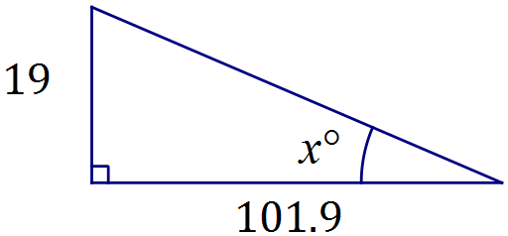

$$\tan{x}=\frac{19}{101.9}⇒x=10.6°$$

Specific behaviours
sketch with new measurements
uses tangent ratio
states angle

Question 10 (6 marks)
The network below shows direct bus services between five city landmarks, $A, B, C, D$ and $E$. For example, a direct bus service exists between $A$ and $B$ but not between $A$ and $C$.

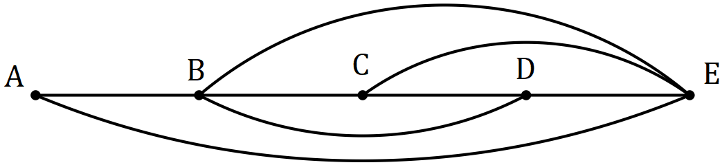

(a) Represent this information in a $5×5$ matrix $M$, with row and column headings in alphabetical order. (2 marks)

Solution
$$M=\left[\begin{matrix}0 & 1 & 0 & 0 & 1 \\ 1 & 0 & 1 & 1 & 1 \\ 0 & 1 & 0 & 1 & 1 \\ 0 & 1 & 1 & 0 & 1 \\ 1 & 1 & 1 & 1 & 0\end{matrix}\right]$$

Specific behaviours
at least 3 correct rows
all rows correct

(b) Calculate $M^{2}$, state the value of entry $M_{2,5}^{2}$ and explain what this value means. (3 marks)
Solution
$$M^{2}=\left[\begin{matrix}2 & 1 & 2 & 2 & 1 \\ 1 & 4 & 2 & 2 & 3 \\ 2 & 2 & 3 & 2 & 2 \\ 2 & 2 & 2 & 3 & 2 \\ 1 & 3 & 2 & 2 & 4\end{matrix}\right]$$

$$M_{2,5}^{2}=3$$

There are 3 ways to travel from $B$ to $E$ using 2 bus services.

Specific behaviours
correct matrix
correct element
explanation

(c) In how many ways is it possible to use four bus services to start a journey at $B$ and finish at $A$? (1 mark)
Solution
$$17 \text{ways} \text{(using} M^{4})$$

Specific behaviours
correct number of ways

Question 11 (8 marks)
The net shown below, made from four rectangles and two trapeziums, is folded to form a scale model of a shed with a sloping roof.
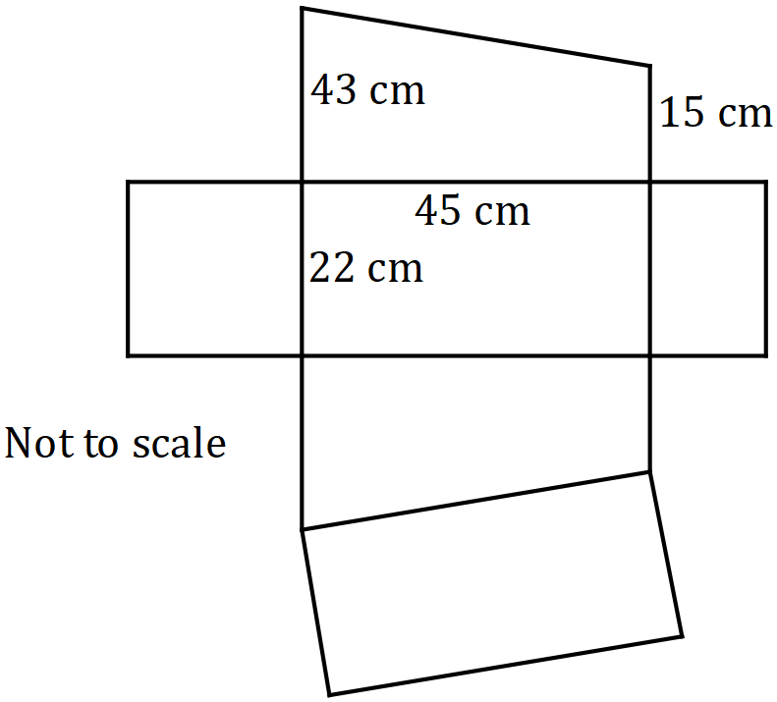

(a) Calculate the volume of the completed model. (3 marks)
Solution
$$A_{TRAP}=\frac{43+15}{2}×45$$
$$=1 305$$

$$V=1 305×22=28 710 {\text{cm}}^{3}$$

Specific behaviours
uses trapezium as cross-section
calculates area of trapezium
calculates volume

(b) Determine the total surface area of the completed model. (5 marks)
Solution
Three rectangles: $A_{1}=22×\left(43+45+15\right)=2266$

Triangle: $43-15=28, ⊿ 28 \text{by} 45$

Sloping edge: $x=\sqrt{{28}^{2}+{45}^{2}}=53$

Roof area: $A_{2}=53×22=1166$

TSA: $A=2266+1166+2×1305=6 042 {\text{cm}}^{2}$

Specific behaviours
calculates areas of three rectangles
dimensions of triangle
uses Pythagoras' theorem for length of roof
area of roof
sums six areas for TSA

Question 12 (9 marks)
A young person won $20 000. Not needing the money immediately, they bought 1 500 AAE shares, 900 TTF shares and placed the remaining $3 200 in a deposit account.

(a) During the first year, dividends were paid of 32 cents per share for AAE and of 3.5% on the value of the TTF shares, which were priced at $13.60 at the time. Calculate the total dividend paid. (3 marks)
Solution
AAE: $1500×0.32=\$480$
TTF: $900×13.60=\$12240, 12240×0.035=428.40$
Total: $480+428.40=\$908.40$

Specific behaviours
dividend per share
dividend as %
total dividend

(b) The deposit account paid 2.5% per annum interest, compounded annually. Calculate the interest that would accumulate in the account

(i) during the first year. (1 mark)
Solution
$$I=3200×0.025=\$80$$

Specific behaviours
uses simple interest

(ii) during the second year. (2 marks)
Solution
$$P=3200+80=4280$$
$$I=3280×0.025=\$82$$

Specific behaviours
new principle
states interest

(c) After two years the young person valued the total of their shares, the dividends received and the money in the deposit account at $22 541.50. Calculate, to one decimal place, the percentage increase in the value of their winnings. (3 marks)
Solution
$$\text{Gain}=22541.50-20000=2541.50$$

$$\text{\%Inc}=2541.50÷20000×100=12.7075\%$$

$$\text{\%Increase}=12.7\% \left(1\text{dp}\right)$$

Specific behaviours
indicates increase
calculates percentage
rounds correctly

Question 13 (7 marks)
A scientific study showed that the lengths of a species of caterpillars are normally distributed with a mean and standard deviation of 5.35 cm and 0.42 cm respectively.

(a) If a caterpillar is selected at random from those in the study, determine the probability that it's length is

(i) less than 5 cm. (1 mark)
Solution
$$P\left(X<5\right)=0.202$$

Specific behaviours
correct probability

(ii) within 0.6 cm of the mean. (2 marks)
Solution
$$P\left(4.75<X<5.95\right)=0.847$$

Specific behaviours
indicates lower and upper bounds
correct probability

(b) If the lengths of 95% of the caterpillars were between $5.35-L$ cm and $5.35+L$ cm, determine the value of $L$. (2 marks)
Solution
$$95\%⇒±2\text{sd}$$
$$L=2×0.42=0.84 \text{cm}$$

Specific behaviours
indicates within 2 sd of mean
states $L$

(c) If 250 caterpillars were selected at random, how many would be expected to have lengths of at least 6 cm? (2 marks)
Solution
$$P\left(X>6\right)=0.061$$
$$0.061×250≈15 \text{caterpillars}$$

Specific behaviours
calculates proportion
states correct whole number

Question 14 (10 marks)
The spreadsheet below shows the wages sheet for some of the staff at a restaurant that is closed on Mondays and Tuesdays. Employees are paid time-and-a-quarter on Saturdays and time-and-a-half on Sundays.

 |  |  | Hours worked
Employee | Base Pay Rate |  | Wed | Thu | Fri | Sat | Sun | Weekly Pay
 | ($ per hour) | Rate | 1 | 1 | 1 | 1.25 | 1.5 | ($)
Ahn | 17.50 |  | 7 | 8 | 8 | 0 | 0 | A
Billy |  |  | 0 | 0 | 0 | 8 | 8 | 334.40
Chris | 22.90 |  | 6 | 6 | 6 | 6 | 0 | B
Dhu | 17.50 |  | 0 | 6 | C | 0 | 4 | 245.00
Eosin | 22.90 |  | 0 | 6 | 6 | 6 | 6 | 652.65

(a) Calculate the total wages paid to employees on Wednesday. (2 marks)
Solution
$$7×17.50+6×22.90=122.50+137.40=\$259.90$$

Specific behaviours
uses correct rates and hours
correct total

(b) Determine the values of A, B and C in the table. (4 marks)
Solution
$$A=17.50\left(7+8+8\right)=17.50\left(23\right)=\$402.50$$

$$B=22.90\left(6+6+6+6×1.25\right)=22.90\left(25.5\right)=\$583.95$$

$$17.50\left(6+C+4×1.5\right)=245.00⇒C=2$$

Specific behaviours
value of A
value of B
calculates total hours or writes equation for Dhu
value of C

(c) The restaurant is liable for payroll tax at a rate of 5.5% of all staff payments. Calculate the payroll tax the restaurant must pay this week for the five employees. (2 marks)
Solution
$$\text{Total}=2218.50. 2218.50×0.055=\$122.02$$

Specific behaviours
correct total
multiplies total by 0.055, rounding to dollars and cents

(d) Determine Billy's base rate of pay. (2 marks)
Solution
$$8×1.25+8×1.5=22 \text{hours}$$
$$334.40÷22=\$15.20 \text{per hour}$$

Specific behaviours
total weighted hours
states hourly rate

Question 15 (7 marks)
The number of nights that visitors booked into a hotel for on the first day in May this year are summarised in the table below.

Number of nights | 1 | 2 | 3 | 4 | 5 | 6 | 7 | 8 | 9
Frequency | 21 | 25 | 12 | 10 | 4 | 8 | 3 | 0 | 1

(a) For this data, determine

(i) the total number of nights booked by visitors. (1 mark)
Solution
Total nights: 245

Mean: 2.92 nights

SD: 1.86 nights

Specific behaviours
states number of nights
states mean
states SD

(ii) the mean number of nights booked. (1 mark)

(iii) the standard deviation of the number of nights booked. (1 mark)

(b) Briefly comment on the distribution of this data. (1 mark)
Solution
The data is positively skewed.

Specific behaviours
identifies positive skew

(c) Identify, with justification, whether the data contains an outlier. (3 marks)
Solution
$$IQR=4-1.5=2.5$$

$$Q_{3}+1.5\left(2.5\right)=4+3.75=7.75$$

Hence the booking for 9 nights is an outlier, as it exceeds 7.75.

Specific behaviours
indicates IQR
uses $Q_{3}+1.5\text{IQR}$ criteria
identifies outlier

Question 16 (9 marks)
Seven equilateral triangles are joined together to make a trapezium $ABCD$ with perimeter of length 162 cm, as shown below.

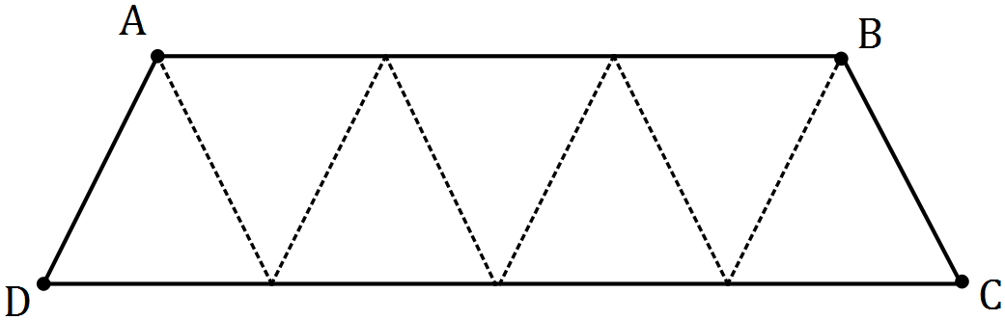

(a) Explain why the sides of each triangle must be 18 cm long. (2 marks)
Solution
There are 9 equal length sides making the perimeter. So $162÷9=18$ cm.

Specific behaviours
indicates 9 equal length sides
uses division

(b) Use Heron's rule to calculate the area of one of the triangles. (3 marks)
Solution
$$s=\frac{18+18+18}{2}=27 \\ A=\sqrt{27\left(27-18\right)\left(27-18\right)\left(27-18\right)} \\ A=140.3 {\text{cm}}^{2}$$

Specific behaviours
calculates semi-perimeter
substitutes into Heron's
calculates area

(c) Determine the area of the trapezium. (1 mark)
Solution
$$TA=7×140.3=982.1 {\text{cm}}^{2}$$

Specific behaviours
states area

(d) Determine the length of diagonal $AC$ in the trapezium. (3 marks)
Solution
$$AB=54, BC=18, ∠ABC=120° \\ AC^{2}=54^{2}+{18}^{2}-2\left(54\right)\left(18\right)\cos{120°} \\ AC=64.9 \text{cm}$$

Specific behaviours
indicates lengths $AB$, $AC$ and angle $ABC$
uses cosine rule
states length

Question 17 (8 marks)
The diagram shows points $A, B$ and $C$ on the circumference of a circle with centre $O$ and radius $25$ cm. Angle $BOC$ and angle $BOA$ are both $145$°.

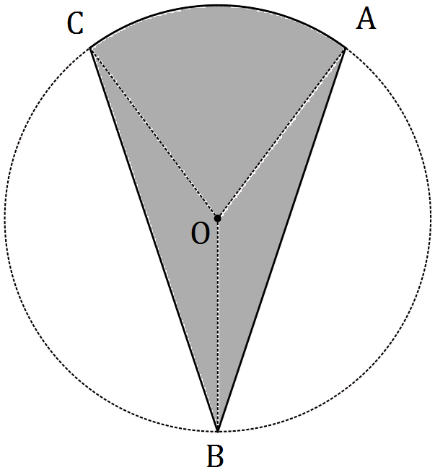

(a) Calculate the area of triangle $BOA$. (2 marks)
Solution
$$A=\frac{1}{2}\left(25\right)\left(25\right)\sin{145°}$$
$$=179 {\text{cm}}^{2}$$

Specific behaviours
uses area formula
states area

(b) Determine the size of angle $AOC$. (1 mark)
Solution
$$360-145-145=70°$$

Specific behaviours
states angle

(c) Calculate the area of the shaded region $ABC$. (3 marks)
Solution
$$A_{s}=\frac{70}{360}×π×{25}^{2}$$
$$=382$$

$$A=2×179+382$$
$$=740 {\text{cm}}^{2}$$

Specific behaviours
substitutes into sector area formula
calculates sector area
calculates total area

(d) Determine the new area of the shaded region if the radius of the circle was increased from $25$ cm to $75$ cm. (2 marks)
Solution
$$\text{sf}=75÷25=3$$
$$\text{New area}=740×3^{2}=6 660 {\text{cm}}^{2}$$

Specific behaviours
indicates scale factor
states new area

Question 18 (9 marks)
Some currency exchange rates advertised by an Australian bank for one Australian dollar are shown in the table below.

Country (currency) | Buy rate | Sell rate
Denmark (kroner) | 5.8220 | 4.4210
Switzerland (franc) | 0.8850 | 0.7110
South Korea (won) | 872.7557 | 768.4547
Thailand (baht) | 28.3350 | 24.8850

(a) The midrate is the average of the buy and sell rates. Calculate the midrate for Swiss franc. (1 mark)
Solution
$$(0.8850+0.7110)÷2=0.7980$$

Specific behaviours
states midrate

(b) If a Swiss tourist in Australia wanted to exchange 530 francs for Australian currency, explain why the bank would use the buy rate, and calculate how many Australian dollars they would receive. (2 marks)
Solution
The bank is buying foreign currency, so will use buy rate.

$$530÷0.8850=\$598.87$$

Specific behaviours
explains rates quoted from banks point of view
calculates amount

(c) The same product, including shipping, can be bought online from a South Korean website for 175 000 won or a Danish website for 900 kroner. Compare these prices in dollars for an Australian purchaser and calculate the amount saved by buying from the cheaper site.
(3 marks)
Solution
$$900÷4.4210=\$203.57$$
$$175000÷768.4547=\$227.73$$
$$\text{Saving}=227.73-203.57=\$24.16$$

Specific behaviours
uses sell rates for conversions
converts both to AUD
states saving

(d) An Australian traveller exchanged $900 into Thai baht, spent 18 000 baht whilst away and then converted the remainder back into Australian dollars on their return. How much did the traveller receive back? (3 marks)
Solution
$$900×24.8850=22396.5 \text{baht}$$
$$22396.5-18000=4396.5 \text{baht}$$
$$4396.5÷28.3350=\$155.16$$

Specific behaviours
uses correct rates both ways
converts to baht and subtracts spending
converts back to AUD

Question 19 (8 marks)
Two similar cylindrical containers, both open at the top and full of water, are made from thin steel. The smaller container has an internal radius of 40 cm and height of 30 cm, and the larger a radius of 92 cm.

Neither cylinder, shown below, has a lid.

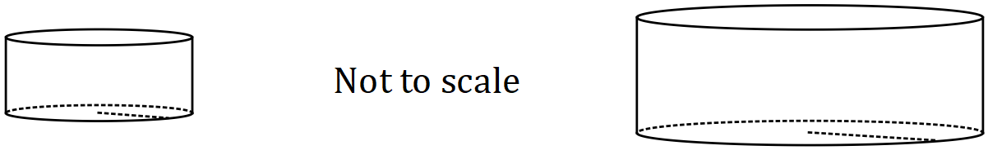

(a) Using the fact that the cylinders are similar, determine the height of the large cylinder.
(2 marks)
Solution
$$\text{Length scale factor: }92÷40=2.3$$

$$h=30×2.3=69 \text{cm}$$

Specific behaviours
indicates scale factor (or ratio of dimensions)
states height

(b) Calculate the internal surface area (the area in contact with water) of the small cylinder.
(2 marks)
Solution
$$A=π×{40}^{2}+2×π×40×30$$
$$A=5027+7540=12567≈12600 {\text{cm}}^{2}$$

Specific behaviours
indicates sum of base and wall
states area, reasonable rounding

(c) 300 mL of paint was required to coat the inside of the small cylinder. Determine how much paint was required to coat (to the same thickness) the inside of the larger cylinder.
(2 marks)
Solution
$$300×{2.3}^{2}=1587 \text{mL}$$

Specific behaviours
uses area scale factor
states amount

The small cylinder is emptied and water from the large cylinder is then used to refill the small cylinder.

(d) How many times can the water from the large cylinder be used to completely refill the small cylinder? Justify your answer. (2 marks)
Solution
$$V_{L}={2.3}^{3}×V_{S}$$
$$2.3^{3}=12.167⇒\text{can refill 12 times}$$

Specific behaviours
uses volume scale factor
states correct number

Additional working space

Question number: _________

Additional working space

Question number: _________

Additional working space

Question number: _________

Additional working space

Question number: _________

© 2017 WA Exam Papers. Baldivis Secondary College has a non-exclusive licence to copy and communicate this document for non-commercial, educational use within the school. No other copying, communication or use is permitted without the express written permission of WA Exam Papers. SN261-103-4.

